RSID Management in EASE

Multiple RSID issue | In IMA some CLEC customers utilize multiple RSIDs.  Example: CLEC ABC, may have the IMA RSIDs of ABC, BCD, CDE, I29, Z32 and the associated OCNs.  Option 1) A CLEC could choose to obtain sign-on into EASE for each RSID. That would limit the visibility of order information to only that RSID and the associated OCNs.  Option 2) To provide a CLEC view to see all RSIDs, the CLEC would obtain a combined sign-on that represents all the RSIDs and OCN combinations.

Option 1 | This method is discussed in the EASE LSR User Guide. The user would sign into EASE, Select the RSID in the ESP drop-down and enter the needed EASE fields for the request.

Option 2 | The following steps should be used to create an order in EASE when the CLEC has multiple RSIDs.  Step Action  1 Log into EASE using the assigned user ID for the combined RSID. In this example, we are going to use the user ID of USER1 for RSID ABC (representing combined ordering for ABC, BCD, CDE, I29 and Z32) 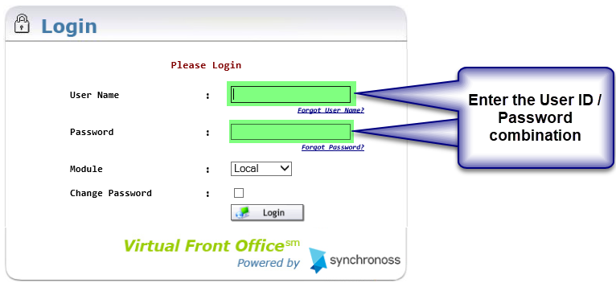  2 Begin the EASE order by selecting the appropriate fields. 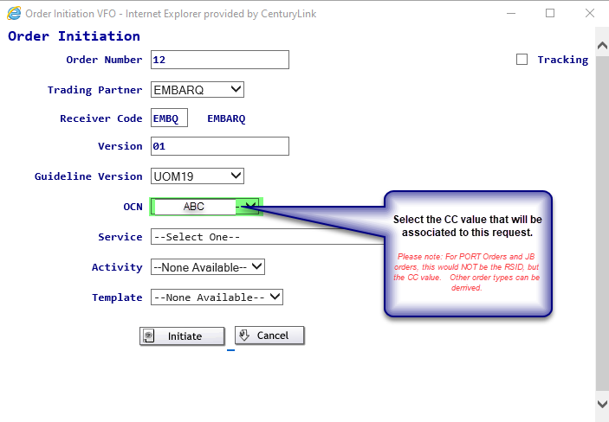 The remaining fields would be selected for the service / activity being requested.  3 From the main screen of EASE, CC field will be auto populated automatically. The CCNA field will be blank. Please Note: When doing JB and PORT OUT orders – this field must contain the correct CC value. 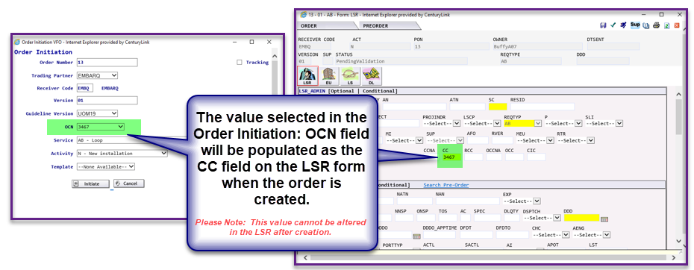  4 The CCNA field will be used to represent the IMA ownership. In most cases, this will be the RSID that the order will be associated with. 